Lab Evaluation:

Course Name: Object Oriented Programming |  |  |  | Course Code: CMPE221L
Assignment Type: Lab |  |  |  | Dated: 1-07-2026
Semester: 2nd |  |  |  | Session: 2025
Lab/Project/Assignment #: 2 |  |  |  | CLOs to be covered: CLO1
Lab Title: Core concepts of Java |  |  |  | Teacher Name: Hafiz Muhammad Mubashar
CLO 1 | The manual provides a comprehensive guide to the core concepts of Java, based on the standard curriculum. Java is a popular, object-oriented programming language used for developing mobile apps, web apps, desktop apps, games, and much more.
Levels (Marks) | Level 1 | Level 2 | Level 3 |  | Level 4 | Level 5 | Level 6
(10)
Total |  |  |  |  |  |  | /10

Rubrics for Current Lab Evaluation
Scale | Marks | Level | Rubric
Excellent | 9-10 | L1 | Submitted all lab tasks, BONUS task, have good understanding.
Very Good | 7-8 | L2 | Submitted the lab tasks but have good understanding
Good | 5-6 | L3 | Submitted the lab tasks but have weak understanding.
Basic | 3-4 | L4 | Submitted the lab tasks but have no understanding.
Barely  Acceptable | 1-2 | L5 | Submitted only one lab task.
Not Acceptable | 0 | L6 | Did not attempt

LAB No.2

Java Programming Manual: Fundamentals

Syntax
Java code is written inside classes. The filename must match the class name followed by .java.

public class Main {
public static void main(String[] args) { System.out.println("Hello World");
}
}
  - public class Main: Every line of code that runs in Java must be inside a class.
  - main() method: This is the entry point of any Java program. Any code inside its curly brackets {} will be executed.

Output
To print text to the console, use the System.out.println() or System.out.print() methods.
  - println(): Adds a new line after the output.
  - print(): Does not insert a new line at the end. Java
System.out.println("Line One"); System.out.print("This stays on "); System.out.print("the same line.");

Comments
Comments are used to explain code and make it more readable. They are ignored by the compiler.
  - Single-line: Starts with //.
  - Multi-line: Starts with /* and ends with */. Java
// This is a single-line comment
/* This is a multi-line comment used for longer descriptions */

Variables
Variables are containers for storing data values. In Java, you must specify the type.
  - String: Stores text (e.g., "Mujtaba").
  - int: Stores integers (e.g., 123).
  - float: Stores floating-point numbers (e.g., 19.99).
  - char: Stores single characters (e.g., 'a').
  - boolean: Stores true or false. Syntax: type variableName = value; Java
String name = "Mujtaba"; int myNum = 15;

Data Types
Data types are divided into two groups:
- Primitive data types: Includes byte, short, int, long, float, double, boolean, and char.
- Non-primitive data types: Includes String, Arrays, and Classes.

Type Casting
Type casting is assigning a value of one primitive data type to another type.
  - Widening Casting (automatically): Smaller type to a larger type size. byte -> short -> char -> int -> long -> float -> double
int myInt = 9;
double myDouble = myInt; // Automatically casting: int to double
  - Narrowing Casting (manually): Larger type to a smaller size type. double -> float -> long -> int -> char -> short -> byte
Java
double myDouble = 9.78d;
int myInt = (int) myDouble; // Manual casting: double to int

Operators
Operators are used to perform operations on variables and values.
  - Arithmetic: +, -, *, /, %, ++, --
  - Assignment: =, +=, -=, *=, /=
  - Comparison: ==, !=, >, <, >=, <=
  - Logical: && (and), || (or), ! (not)

Strings
A String in Java is an object that contains a collection of characters.
  - Length: txt.length()
  - Case: txt.toUpperCase(), txt.toLowerCase()
  - Find: txt.indexOf("word")
  - Concatenation: Using the + operator or concat(). String firstName = "John ";
String lastName = "Doe";
System.out.println(firstName.concat(lastName));

Math Class:
The Math class allows you to perform mathematical tasks on numbers.
  - Math.max(x, y): Finds the highest value.
  - Math.min(x, y): Finds the lowest value.
  - Math.sqrt(x): Returns the square root.
  - Math.abs(x): Returns the absolute (positive) value.
  - Math.random(): Returns a random number between 0.0 and 1.0.

Booleans
A boolean type is declared with the boolean keyword and can only take the values true or false. This is mostly used for conditional testing.
Java
boolean isJavaFun = true;
System.out.println(10 > 9); // Returns true

If...Else
Use conditional statements to perform different actions based on different conditions.
  - if: Executes code if a condition is true.
  - else: Executes code if the condition is false.
  - else if: Specifies a new condition if the first is false. int time = 20;
if (time < 18) {
System.out.println("Good day.");
} else {
System.out.println("Good evening.");
}

Java Switch
Use the switch statement to select one of many code blocks to be executed.
Java
int day = 2;
switch (day) { case 1:
System.out.println("Monday"); break;
case 2:
System.out.println("Tuesday"); break;
default:
System.out.println("Looking forward to the Weekend");
}
- The break keyword breaks out of the switch block.
- The default keyword specifies code to run if there is no case match.
This lab series is designed to take you from basic syntax to intermediate logical problem-solving. Each task focuses on a specific set of concepts from your manual.

Task 1: The Geometry Calculator (Operators & Math)
Objective: Use Math methods and arithmetic operators.
- Create a program that stores the radius of a circle as a double.
- Calculate the area ($Area = \pi \times r^2$). Use Math.PI and Math.pow().
- Print the result. Then, use Type Casting to print the area as a whole integer.

Task 2: String Analysis Tool (Strings)
Objective: Manipulate and analyze text data.
- Create a String variable fullName containing your first and last name.
- Print the length of the string.
- Convert the name to all uppercase.
- Use indexOf() to find the position of the space between the names.
Task 3: Automatic Grade Converter (Type Casting) Objective: Practice Narrowing Casting and Output.
- Declare a double variable percentage = 85.99.
- Manually cast this percentage into an int.
- Print: "Your raw score is: 85.99% but your rounded grade is: 85%".
Task 4: The Logical Gatekeeper (Logical Operators) Objective: Use &&, ||, and !.
- Create two boolean variables: hasID and isOver18.
- Write an if statement that prints "Access Granted" only if both are true.
- Write another statement that prints "Special Guest" if they have an ID OR they are over 18.
Task 5: Random Number Matcher (Math & Booleans) Objective: Use Math.random() and comparisons.
- Generate a random number between 1 and 10. Hint: Use (int)(Math.random() * 11).
- Declare a variable userGuess = 5.
- Print true if the random number matches the guess, otherwise print false.
Task 6: Personalized Greeting (Strings & Concatenation) Objective: Use different methods of string joining.
- Create variables for greeting, firstName, and lastName.
- Use the + operator to join them for one output.
- Use the .concat() method to join them for a second output.

Task 7: Time-of-Day Identifier (If...Else If) Objective: Use conditional chains.
- Store an int variable hour (0 to 23).
- If hour is between 5 and 11, print "Good Morning".
- Else if hour is between 12 and 17, print "Good Afternoon".
- Else if hour is between 18 and 23, print "Good Evening".
- Use else to handle any other numbers as "Invalid Hour".
Task 8: The Currency Switcher (Switch Case) Objective: Practice multi-way branching.
- Create a variable String currency = "USD".
- Use a switch statement to print the full name of the currency:
  - "USD" -> "United States Dollar"
  - "GBP" -> "British Pound"
  - "EUR" -> "Euro"
  - Default -> "Unknown Currency" Task 9: Comparison & Increment Lab (Operators) Objective: Understand how values change.
- Declare int x = 10 and int y = 20.
- Use a comparison operator to print if x is not equal to y.
- Apply the increment operator ++ to x.
- Print the new value of x and check if it is now greater than 10.

TASK 1:
import java.util.Scanner;
public class radius {
public static void main(String[] args){
Scanner sc = new Scanner(System.in);
System.out.println("enter radius");
double radius = sc.nextDouble();
double area = Math.PI * Math.pow(radius,2);
System.out.println("the area is" + area);
int ar = (int) area;
System.out.println("the area in whole number is" + ar);

}
}

RESULT:
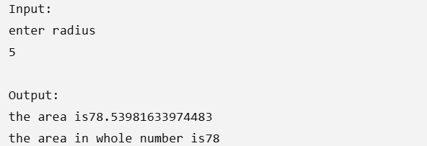

TASK 2:
public class string {
public static void main(String[] args){
String firstname = "umair";
String lastname = "toor";
String fullname= firstname + " " + lastname;
System.out.println("the length of the name is" + fullname.length());
System.out.println("the uppercase of fullname is" + fullname.toUpperCase());
System.out.println("the index of the given word is" + fullname.indexOf("t"));
}
}

RESULT:
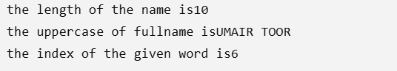

TASK 3:
public class typecasting {
public static void main(String[] args){
double percentage = 85.99;
int per = (int) percentage;
System.out.println( "Your raw score is:" + percentage +"but your rounded grade is:" + per);
}
}
RESULT:

TASK 4:
public class logical {
public static void main(String[] args){
boolean hasID= true;
boolean isOver18= false;
if(hasID && isOver18){
System.out.println("Access Granted");
}else if(hasID || isOver18){
System.out.println("Special Guest");
}
}
}

RESULT:
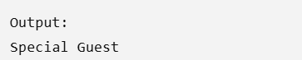

TASK 5:
import java.util.Scanner;
public class random {
public static void main(String[] args){
Scanner sc= new Scanner(System.in);
int random= (int)(Math.random() * 11);
System.out.println("enter the number");
int userguess= sc.nextInt();
System.out.println("the number you entered" + userguess);
if(userguess == random){
System.out.println("you guessed correct");
}else{
System.out.println("try again");
}

}
}
RESULT:
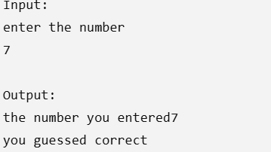

TASK 6:
public class greeting {
public static void main(String[] args){
String greeting = "Hello my name is";
String firstname = "umair";
String lastname = "toor";
System.out.println(greeting + " " + firstname + " " + lastname);
System.out.println(greeting.concat(firstname.concat(lastname)));
}
}

RESULT:
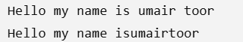

TASK 7:
public class timeday {
public static void main(String[] args){
int random = (int)(Math.random() * 24);
if(random>=5 && random<=11){
System.out.println("Good morning");

} else if (random>=12 && random<= 17) {
System.out.println("Good afternoon");
} else if (random>=18 && random<=23) {
System.out.println("Good evening");

}else{
System.out.println("invalid hour");
}

}
}

RESULT:
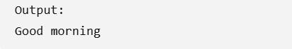

TASK 8:
import java.util.Scanner;
public class currency {
public static void main(String[] args){
Scanner sc= new Scanner(System.in);
System.out.println("enter the currency");
int currency = sc.nextInt();
switch (currency){
case 1:
String usd = "united states dollar";
System.out.println(usd);
break;
case 2:
String gbp = "british pound";
System.out.println(gbp);
break;
case 3:
String eur = "euro";
System.out.println(eur);
break;

default:
System.out.println("invalid currency");

}

}
}

RESULT:
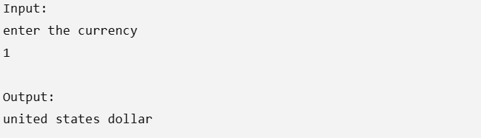

TASK 9:
public class comparison {
public static void main(String[] args){
int x = 10;
int y = 20;
if(x!= y){
++x;
System.out.println(x);

}if(x>10){
System.out.println("x is greater than 10");

}
}
}

RESULT:


CONCLUSION:
These programs demonstrate important intermediate Java programming concepts, including type casting, string manipulation, mathematical functions, logical and comparison operators, random number generation, conditional statements (if-else and switch), and user interaction through the Scanner class. They perform practical tasks such as converting data types, manipulating strings, calculating the area of a circle, checking logical conditions, generating random values, displaying greetings based on time, selecting currencies using a switch statement, and comparing values. Overall, these programs strengthen the understanding of Java syntax, built-in methods, decision-making, and problem-solving skills, providing a solid foundation for developing more advanced Java applications.

